DBMS Mini Project Report

Space Database

Pranav Ambiga : PES1UG21CS434

Purab N : PES1UG21CS459

Abstract

Cosmo is an immersive and educational space exploration website designed to captivate users with the wonders of the cosmos. Offering a comprehensive journey through our galaxy and beyond, the website provides detailed information on various celestial bodies, including planets, moons, stars, asteroids, and galaxies. Users can navigate through visually stunning representations of the universe, access real-time data on astronomical phenomena, and engage in interactive learning experiences. With features like Dynamic queries, and a user-friendly interface, Cosmo transforms complex astrophysical concepts into an accessible and engaging learning adventure. Whether a casual stargazer or a budding astronomer, users of all ages can embark on a captivating journey to deepen their understanding of the vastness and beauty of the cosmos.

Technologies Used

1. MySQL
2. Flask
3. Python
4. React
5. HTML, CSS, JS

ER Diagram

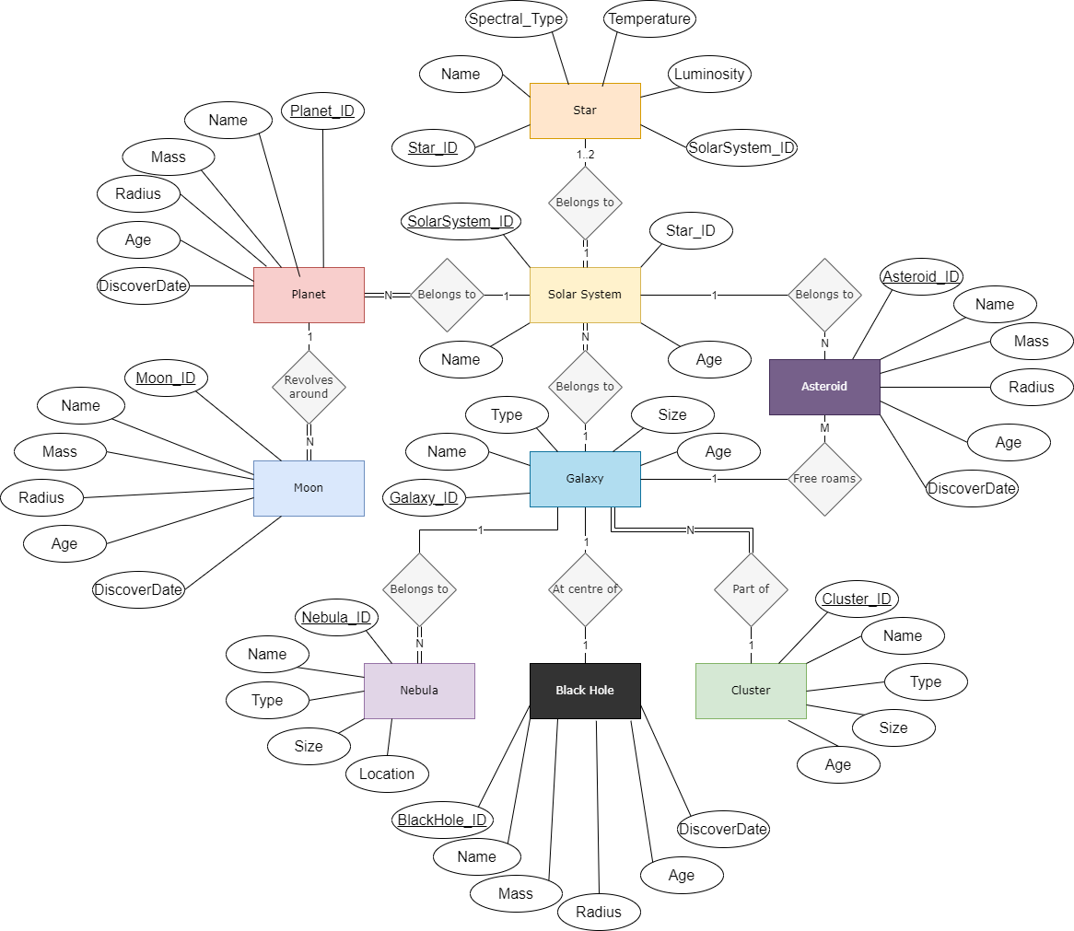

Relational Schema

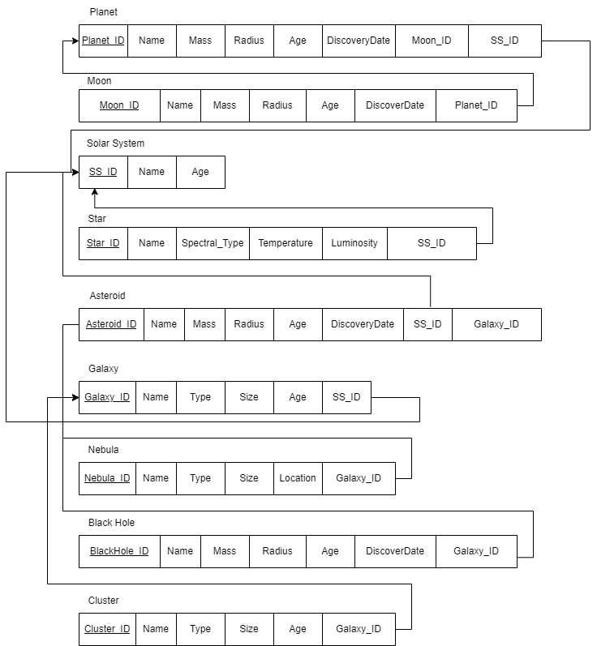

DDL Queries

-- SolarSystems Table

CREATE TABLE SolarSystems (

    SolarSystemID INT PRIMARY KEY,

    Name VARCHAR(255),

    Age INT,

    StarID INT,

    FOREIGN KEY (StarID) REFERENCES Star(StarID)

);

-- Planets Table

CREATE TABLE Planet (

    PlanetID INT PRIMARY KEY,

    Name VARCHAR(255),

    Mass DECIMAL(18, 2),

    Radius DECIMAL(18, 2),

    Age INT,

    DiscoveryDate DATE,

    MoonID INT,

    SolarSystemID INT,

    FOREIGN KEY (SolarSystemID) REFERENCES SolarSystems(SolarSystemID)

);

-- Moons Table

CREATE TABLE Moon (

    MoonID INT PRIMARY KEY,

    Name VARCHAR(255),

    Mass DECIMAL(18, 2),

    Radius DECIMAL(18, 2),

    Age INT,

    DiscoveryDate DATE,

    PlanetID INT,

    FOREIGN KEY (PlanetID) REFERENCES Planet(PlanetID)

);

-- Stars Table

CREATE TABLE Star (

    StarID INT PRIMARY KEY,

    Name VARCHAR(255),

    SpectralType VARCHAR(10),

    Temperature INT,

    Luminosity DECIMAL(18, 2),

    SolarSystemID INT,

    FOREIGN KEY (SolarSystemID) REFERENCES SolarSystems(SolarSystemID)

);

-- Asteroids Table

CREATE TABLE Asteroid (

    AsteroidID INT PRIMARY KEY,

    Name VARCHAR(255),

    Mass DECIMAL(18, 2),

    Radius DECIMAL(18, 2),

    Age INT,

    DiscoveryDate DATE,

    SolarSystemID INT,

    GalaxyID INT,

    FOREIGN KEY (SolarSystemID) REFERENCES SolarSystems(SolarSystemID)

);

-- Nebulae Table

CREATE TABLE Nebula (

    NebulaID INT PRIMARY KEY,

    Name VARCHAR(255),

    Type VARCHAR(50),

    Size DECIMAL(18, 2),

    Location VARCHAR(255),

    GalaxyID INT,

    FOREIGN KEY (GalaxyID) REFERENCES Galaxy(GalaxyID)

);

-- Galaxies Table

CREATE TABLE Galaxy (

    GalaxyID INT PRIMARY KEY,

    Name VARCHAR(255),

    Type VARCHAR(50),

    Size DECIMAL(18, 2),

    Age INT,

    SolarSystemID INT,

    FOREIGN KEY (SolarSystemID) REFERENCES SolarSystems(SolarSystemID)

);

-- BlackHole Table

CREATE TABLE BlackHole (

    BlackHoleID INT PRIMARY KEY,

    Name VARCHAR(255),

    Mass DECIMAL(18, 2),

    Radius DECIMAL(18, 2),

    Age INT,

    DiscoveryDate DATE,

    GalaxyID INT,

    FOREIGN KEY (GalaxyID) REFERENCES Galaxy(GalaxyID)

);

-- LocalGroup Table

CREATE TABLE Cluster (

    ClusterID INT PRIMARY KEY,

    Name VARCHAR(255),

    Type VARCHAR(50),

    Size DECIMAL(18, 2),

    Age INT,

    GalaxyID INT,

    FOREIGN KEY (GalaxyID) REFERENCES Galaxy(GalaxyID)

);

Crud Operations

--Create

INSERT INTO Planet (Name, Mass, Radius, Age, DiscoveryDate, SolarSystemID)

VALUES ('NewPlanet', 10.5, 15.2, 500, '2023-11-24', 1);

--Read

SELECT Moon.Name, Moon.Mass, Moon.Radius

FROM Moon

JOIN Planet ON Moon.PlanetID = Planet.PlanetID

WHERE Planet.Name = 'Jupiter';

--Update

UPDATE Star

SET Temperature = 6000

WHERE StarID = 1;

--Delete

DELETE FROM Asteroid

WHERE AsteroidID = 1;

Functionalities

1. A comprehensive frontend built with React with a Flask backend.
2. Fully routed with 4 pages, Explore, Planets, Stars, Queries
3. Explore features clickable data attributes that start with Earth. Move from one planet to another or its star by clicking the ID associated with it.
4. Planets page features all the planets, same with Stars.
5. Query page features an input box that supports any SQL query. Execution results displayed appropriately.

Screenshots

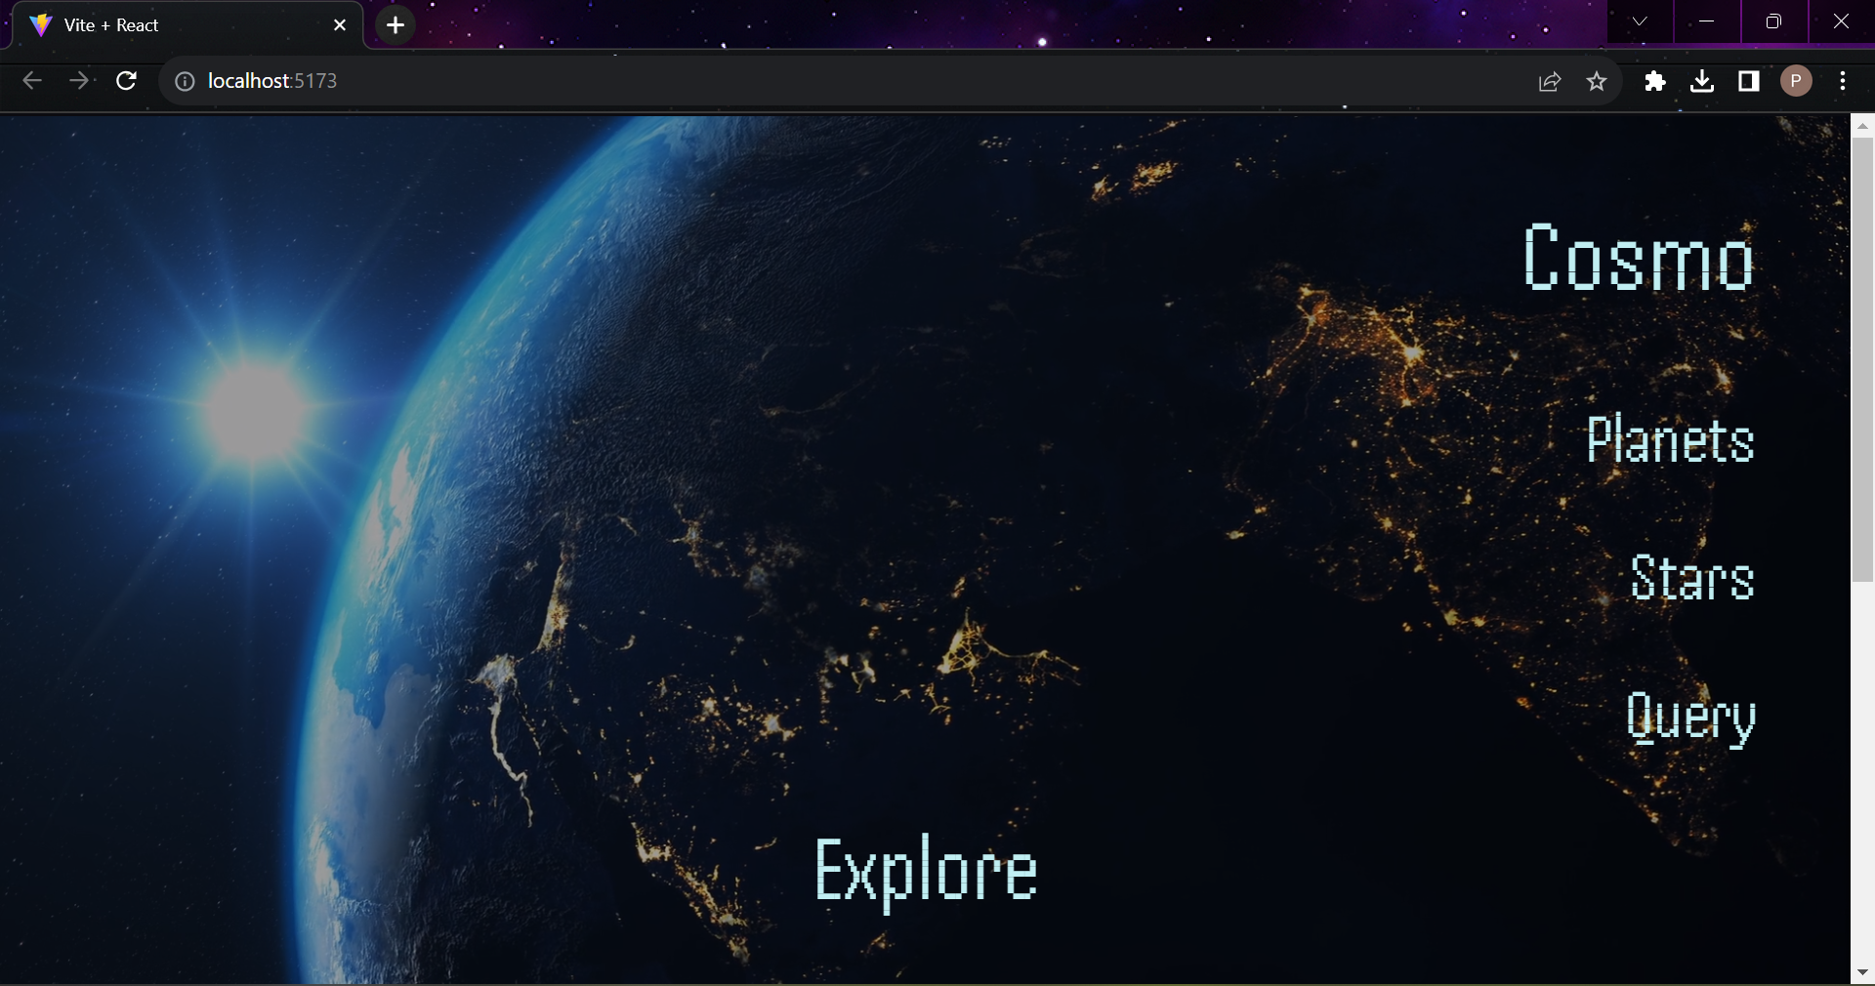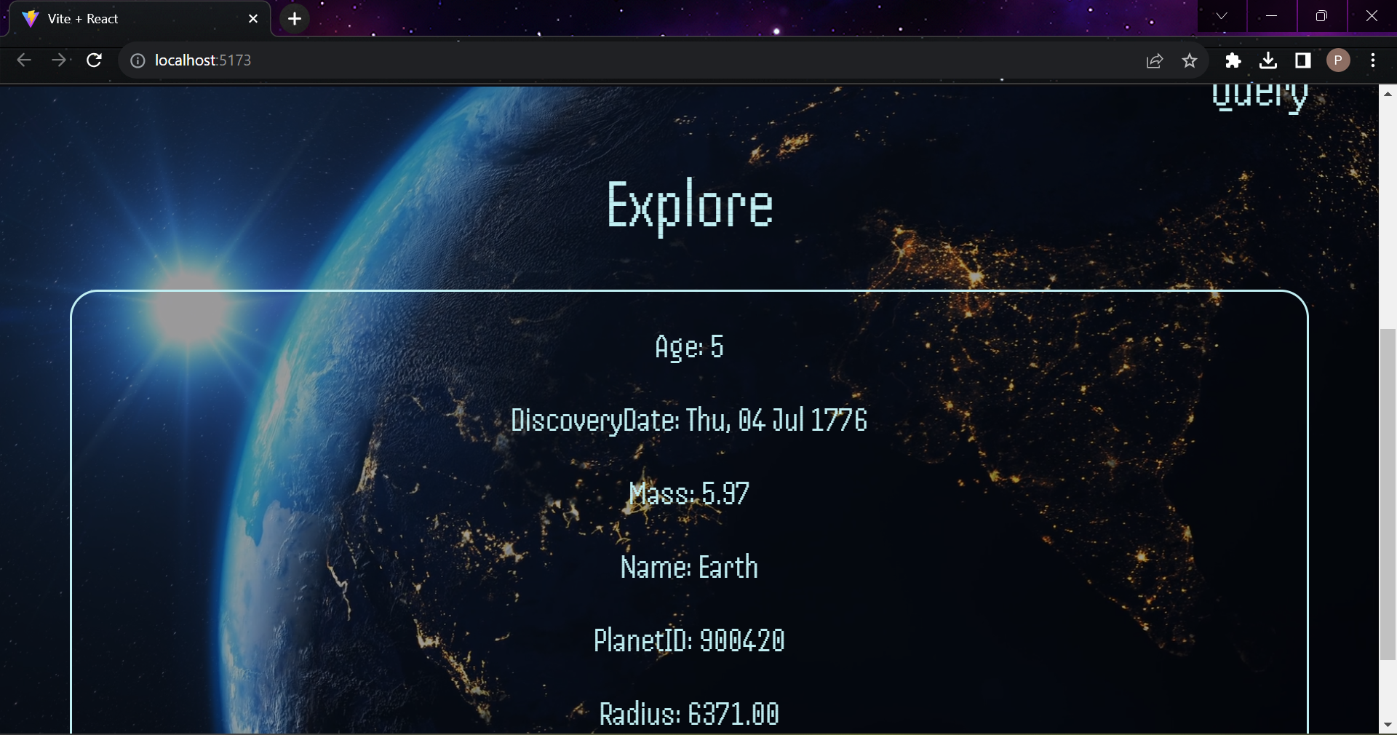

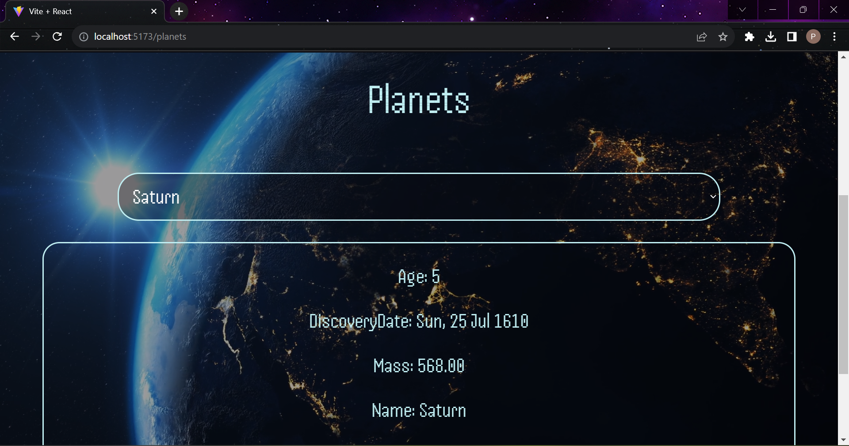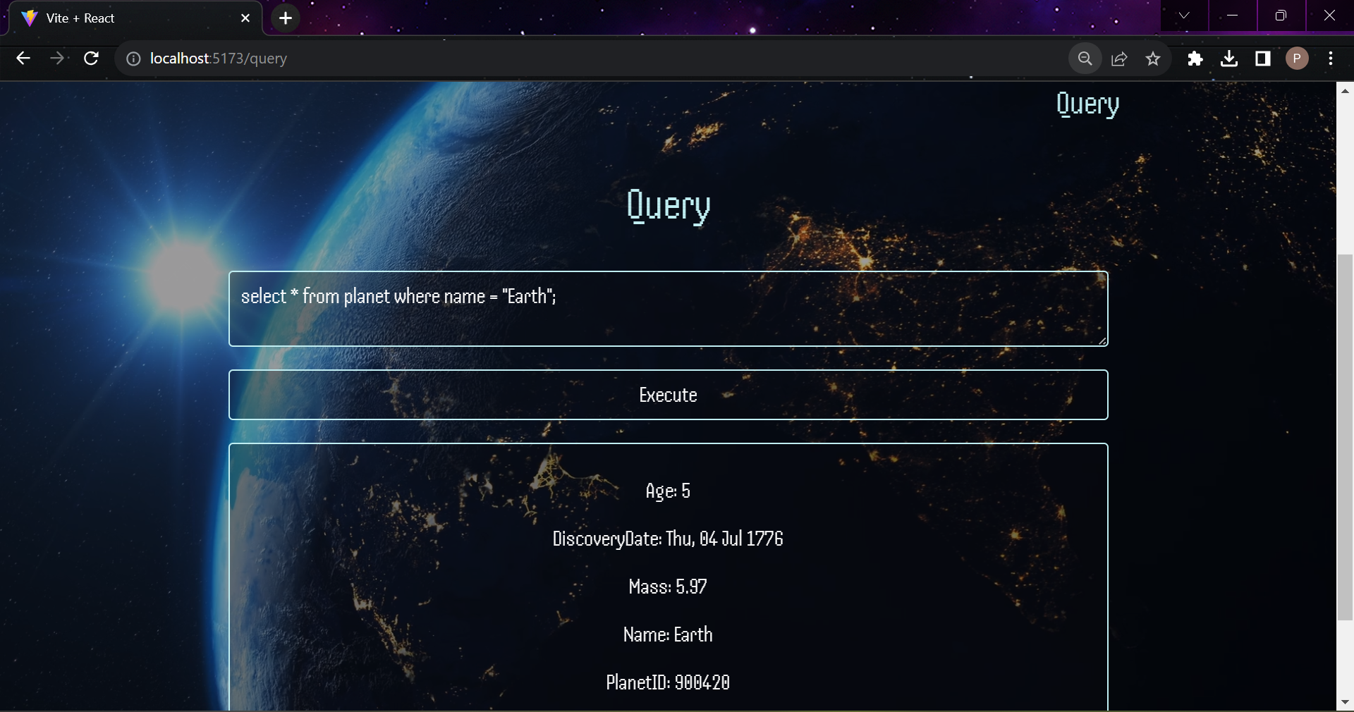

Queries

-- Explore moons of a particular planet:

SELECT Moon.Name, Moon.Mass, Moon.Radius

FROM Moon

JOIN Planet ON Moon.PlanetID = Planet.PlanetID

WHERE Planet.Name = 'Jupiter';

-- Discover stars in a solar system:

SELECT Star.Name, Star.SpectralType, Star.Temperature, Star.Luminosity

FROM Star

JOIN SolarSystem ON Star.SolarSystemID = SolarSystem.SolarSystemID

WHERE SolarSystem.Name = 'Our Solar System';

-- Find stars in each solar system with their spectral type:

SELECT SolarSystem.Name AS SolarSystemName, Star.Name AS StarName, Star.SpectralType

FROM SolarSystem

JOIN Star ON SolarSystem.SolarSystemID = Star.SolarSystemID;

-- Find galaxies with their black holes and associated solar systems:

SELECT Galaxy.Name AS GalaxyName, BlackHole.Name AS BlackHoleName, SolarSystem.Name AS SolarSystemName

FROM Galaxy

LEFT JOIN BlackHole ON Galaxy.GalaxyID = BlackHole.GalaxyID

LEFT JOIN SolarSystem ON Galaxy.SolarSystemID = SolarSystem.SolarSystemID;

-- Find the oldest planet in each solar system--

SELECT SolarSystem.Name AS SolarSystemName, Planet.Name AS OldestPlanet

FROM SolarSystem

JOIN Planet ON SolarSystem.SolarSystemID = Planet.SolarSystemID

WHERE Planet.Age = (SELECT MAX(Age) FROM Planet WHERE SolarSystemID = SolarSystem.SolarSystemID);

-- List moons that are larger than the average moon radius:

SELECT Name, Radius

FROM Moon

WHERE Radius > (SELECT AVG(Radius) FROM Moon);

-- Find galaxies with the largest average black hole mass:

SELECT Galaxy.Name AS GalaxyName, AVG(BlackHole.Mass) AS AvgBlackHoleMass

FROM Galaxy

LEFT JOIN BlackHole ON Galaxy.GalaxyID = BlackHole.GalaxyID

GROUP BY Galaxy.GalaxyID

HAVING AVG(BlackHole.Mass) = (SELECT MAX(AvgMass) FROM (SELECT AVG(Mass) AS AvgMass FROM BlackHole GROUP BY GalaxyID) AS AvgMassPerGalaxy);

-- Create Trigger to Update Total Number of Planets in a Solar System

DELIMITER //

-- Create Trigger to Update Total Number of Planets in a Solar System

CREATE TRIGGER UpdateSolarSystemTotalPlanets

AFTER INSERT ON Planet

FOR EACH ROW

BEGIN

    -- Update the total number of planets in the solar system

    UPDATE SolarSystem

    SET TotalPlanets = (

        SELECT COUNT(*)

        FROM Planet

        WHERE SolarSystemID = NEW.SolarSystemID

    )

    WHERE SolarSystemID = NEW.SolarSystemID;

END//

DELIMITER ;

-- Create Function to Calculate Average Mass of Planets in a Solar System

DELIMITER //

CREATE FUNCTION CalculateAverageMass(solarSystemID INT)

RETURNS DECIMAL(18, 2)

BEGIN

    DECLARE avgMass DECIMAL(18, 2);

    SELECT AVG(Mass) INTO avgMass

    FROM Planet

    WHERE SolarSystemID = solarSystemID;

    RETURN avgMass;

END //

DELIMITER ;

--Nested query that retrieves information about planets

--in solar systems that belong to a specific galaxy

SELECT *

FROM Planet

WHERE SolarSystemID IN (

    SELECT SolarSystemID

    FROM SolarSystem

    WHERE Solarsystem.GalaxyID = (

        SELECT GalaxyID

        FROM Galaxy

        WHERE Name = 'Milky Way'

    )

);

-- Procedure to get all planets of a solarsystem

DELIMITER //

CREATE PROCEDURE GetPlanetsInSolarSystem(IN solarSystemID INT)

BEGIN

    SELECT Name, Mass, Radius

    FROM Planet

    WHERE SolarSystemID = solarSystemID;

END //

DELIMITER ;

--query to find cluster names of all planets

SELECT

    Planet.Name AS PlanetName,

    Cluster.Name AS ClusterName

FROM

    Cluster

JOIN

    Galaxy ON Cluster.GalaxyID = Galaxy.GalaxyID

JOIN

    SolarSystems ON Galaxy.GalaxyID = SolarSystems.GalaxyID

JOIN

    Planet ON SolarSystems.SolarSystemID = Planet.SolarSystemID;